

A major project report on

**LoRa-BASED OVERLOAD DETECTION SYSTEM FOR TRANSPORTATION**

Submitted by

**Anjali Chattopadhyay (1604074)**

**D. Rajesh (1604082)**

**Himanshu Agrawal (1604084)**

**Sahil Sinha (1604102)**

**Sneh Shyambhavi (1604113)**

Under the guidance of:

**Prof. (Dr.) N.K. Rout**

**B.Tech. in Electronics and Telecommunication Engineering**

**School of Electronics Engineering**

**Kalinga Institute of Industrial Technology, Deemed to be University**

**Bhubaneswar, India**

**March 2020**

**CERTIFICATE**

This is to certify that the project report entitled **“LoRa-BASED OVERLOAD DETECTION SYSTEM FOR TRANSPORTATION”** submitted by

|  |  |
| --- | --- |
| **ANJALI CHATTOPADHYAY** | **1604074** |
| **D RAJESH** | **1604082** |
| **HIMANSHU AGRAWAL** | **1604084** |
| **SAHIL SINHA** | **1604102** |
| **SNEH SHYAMBHAVI** | **1604113** |

In partial fulfillment of the requirements for the award of the **Degree of Bachelor of Technology in Electronics and Telecommunication Engineering** is a bonafide record of the work carried out under my(our) guidance and supervision at the School of Electronics Engineering, KIIT University.

Signature of Supervisor

Prof.(Dr.)N.K.Rout

School of Electronics Engineering

KIIT DEEMED to be UNIVERSITY

**Acknowledgment**

We feel immense pleasure and feel privileged in expressing our deepest and most sincere gratitude to our supervisor **Prof. (Dr.) N.K.Rout**, for his excellent guidance throughout our project work. His kindness, dedication, hard work and attention to detail have been a great inspiration to us. Our heartfelt thanks to you Sir for the unlimited support and patience shown to us. We would particularly like to thank him for all his help in patiently and carefully correcting all our manuscripts.

We are also very thankful to **Prof. Ghanashyam Rout, Prof. Jyoti Ranjan Panda, Prof. Sandeep Kumar Dash and Prof. Bhargav Appasani,** our B.tech project coordinators (E&TC), associate Dean **Prof.Dr. Amlan Datta** and **Prof. (Dr.) Arun Kumar Ray**, Dean (School Of Electronics) for their support and suggestions during our course of the project work in the pre-final year of our undergraduate course.

|  |
| --- |
| **ANJALI CHATTOPADHYAY(1604074)** |
| **D RAJESH(1604082)** |
| **HIMANSHU AGRAWAL(1604084)** |
| **SAHIL SINHA(1604102)** |
| **SNEH SHYAMBHAVI(1604113)** |

**ABSTRACT**

In a developing nation like India, with the advancement in transportation technology and a rise in the total number of vehicles, a sharp rise in the road accidents has been observed. Often the main reasons behind this road accidents are lack of driving skills, improper infrastructure to teach driving, lack of information of government regulations, conditions of the roads, using the mobile while driving, driving after consuming alcohol and overloading of the vehicles. Plenty of solutions have been implemented, which includes binding rules and regulations, but they have not been much fruitful. This paper provides an intelligent system for accident prevention due to overloading of vehicles along with a communication module. The overload detection part includes a load cell with proper calibration and an Arduino UNO that sends out a signal to turn off the engine whenever the load on the vehicles crosses a specified threshold and on the communication forefront Bolt Wi-Fi Module along with LoRa has been implemented to send out the vehicle’s information to the nearby police station so that necessary measures can be taken.

**TABLE OF CONTENTS**

Abstract

Table of Contents

List of Figures

|  |  |
| --- | --- |
| Chapter 1: INTRODUCTION | 8 |
| 1.1 Background | 8 |
| 1.2 Organisation of Report | 9 |
| Chapter 2 : PROJECT COMPONENTS | 11 |
| 2.1 Hardware Components | 11 |
| 2.1.1 Load Cells | 12 |
| 2.1.1(a) Classification of Load Cells | 12 |
| 2.1.1(b) Specifications of Load Cells Used | 13 |
| 2.1.1(c) Construction | 14 |
| 2.1.2 HX711 | 15 |
| 2.1.2(a) Features | 16 |
| 2.1.3 Arduino Board | 16 |
| 2.1.3(a) Technical Specifications | 17 |
| 2.1.3(b) General Pin Functions | 18 |
| 2.1.3(c) Communication | 19 |
| 2.1.4 Bolt WiFi Module | 19 |
| 2.1.4(a) Parameters  2.1.7 LoRa based on Chirp Spread Spectrum | 20  23 |
| 2.2 Software Used | 23 |
| 2.2.1 Arduino IDE | 23 |
| 2.2.2 Ubuntu VMWare WorkStation | 24 |
| 2.3 Bolt IoT Cloud Platform | 25 |
| Chapter 3: WORKING OF PROJECT MODEL | 26 |
| 3.1 Circuit Diagram | 26 |
| 3.2 Project Description | 27 |
| 3.2.1 Load Cell to HX711 Connection | 27 |
| 3.2.2 HX711 to Arduino Connection | 27 |
| 3.2.3 Arduino to Bolt IoT Connection | 28 |
| 3.2.4 Arduino to LoRa Connection | 28 |
| 3.3 Working | 28 |
| 3.3.1 Code | 29 |
| Chapter 4 : FUTURE SCOPE OF ENHANCEMENT | 32 |
| 4.1 Using data from Arduino to include Seat-Belt as a Mandate | 32 |
| 4.2 In-built Camera for detection of Black Spot | 33 |
| 4.3 Using Cloud Storage for retrieving a list of Violators | 33 |
| Chapter 5 : CONCLUSION | 35 |
| 5.1 Summary | 35 |
| 5.2 Weight Budget Analysis | 35 |
| 5.3 Cost Analysis | 36 |
| 5.4 Result Images | 37 |
| Chapter 6: PLANNING AND PROJECT MANAGEMENT | 38 |

REFERENCES 40

**LIST OF FIGURES**

|  |  |  |
| --- | --- | --- |
| **Figure No.** | **Description** | **Page No.** |
| 2.1 | Operation of Load Cell | 14 |
| 2.2 | HX711 Load Cell Amplifier | 15 |
| 2.3 | Arduino UNO ATMega328 Board | 17 |
| 2.4 | Bolt WiFi Module | 20 |
| 2.5 | Relay | 22 |
| 2.6 | Power Supply | 22 |
| 2.7 | Rear View of LoRa Module | 23 |
| 3.1 | Circuit Connection | 26 |
| 3.2 | WorkFlow Diagram | 29 |

**CHAPTER 1**

**INTRODUCTION**

**1.1 BACKGROUND**

Most of the goods are transported by road in comparison with other modes of transportation. There has been a significant increase in commercial vehicles on the road in recent times. The increase in commercial vehicles is a reflection of increasing demand for the movement of goods, which is a direct consequence of rapid growing industrialization.

According to the Transport corporation of India one in every third trucks in the country is overweight and they are the reason for 50% of road accidents. In 2015, overloaded trucks accounted for 20% of accidents and in 2016, around 38,370 people were killed because of these overloaded vehicles. In command to decrease the overloading of trucks and road accidents, the Government has taken some major steps. For instance, a penalty has been proposed in the Road Transport and Safety Bill for those who fail to comply with the new rules, with the suspension of license for one month and cancellation of permits if the offense is repeated. But till now no step has been taken regarding the overloading of the vehicles or even if such a step has been thought it has not been implemented for large scale.

**1.2 ORGANIZATION OF THE REPORT**

Road accidents are increasing day by day and it's been a great questioning put in front of public health care agencies. The most striking deaths of today's population are because of road accidents. Many reasons for this accident are indecorous construction and mending of the roads, overcrowding and incorporative count of vehicles. Apart from this, reckless driving,drink and drive and many other complicated matters. . According to the World Health Organization, road traffic injuries caused an estimated 1.25 million deaths worldwide in the year 2010 .Around 464, 000 road accidents in 2015 in India. Maharashtra reported (3, 146) the largest number of people killed in two-wheeler accidents, while UP reported the largest number of lives lost due to (5, 720) truck accidents. A Report on Road Accidents in India 2016, published by TR wing under Ministry of Road Transport & Highways, has revealed that India recorded at least 4.80.652 accidents in 2017, that is at least 413 people died every day in accidents .

The current invention is related to a load indicating devices which can be mounted in trucks,trailers or particularly to an instrument which indicates when the vehicle is loaded with more than licensed limit. The Trucks a serious problem swarm those who operate trucks or other high vehicles are sometimes fined more than the cost of the load carried. A high amount of time is wasted when the vehicle is measured from a nearby scale. Further this time can be used by the truck to carry and earn money between profitable and unprofitable trucking operations.

It is a primary object of this invention is to provide a device mounted on the carrier which will indicate to the carrier operator when a load equals the licensed limit. a further object of this invention is to provide means for producing a warning signal when the load has reached a weight slightly under the licensed limit. Warning means of this nature is particularly advantageous when bulk materials are being loaded on the carrier from a hopper or by means of a conveyor or other high-speed loading equipment.

More specifically, if the loading is stopped in response to an indication that the licensed limit has been reached, it is quite possible that the carrier will still be overloaded if high-speed loading equipment is being used because an interval of time will generally elapse between the moment the limit is indicated and the moment the loading is stopped, and a substantial amount of weight can be loaded with high-speed equipment during this interval, all of which will be, in excess of the licensed limit. By using a warning signal to indicate when the limit is being approached the loading can be stopped in response to this signal, and the load can thereby be prevented from exceeding the limit. Not only in the carriers, but this invention can also be used in any type of vehicle in which safety is concerned. Buses in the remote areas are often overloaded as there is no one to check them and the authorities are often bribed by the private company owners. This invention will directly solve this problem as the data will be shared with related authorities online and the vehicle will automatically stop if it is overloaded. School buses are also often overloaded by the bus drivers in order to gain more profit while risking the life of the students. Mostly, the students who prefer buses are below 15 and they don’t understand the risk.

Another objective of this project is to provide a device which can promptly adjustable to indicate the loading signals for a selected load more than the warning signal has been set.

Our main objective of the present invention is to provide a device which is easy in construction, assemble, cost economical and robust in nature.

**CHAPTER 2**

**PROJECT COMPONENTS**

**2.1 HARDWARE COMPONENTS**

**2.1.1. LOAD CELLS**

Load cells is one the accurate devices used to detect a value that can further be used to calculate the exact weight. Once properly designed and used, they are extremely accurate and reliable sensors. Load cells are applied in variety of different sectors, usually to determine the applied weight. Among several different things, food, vehicles, and animals are weighed daily with load cells. In order to make compression force feedback available to the control system to avoid the break down of the object. The quantity or level of a tank is measured indirectly by utilization of the load cell that monitors the overall weight. Lift units can even have a load’s total weight measured to forestall overload. As a result of such a spread of attainable applications, load cells are extremely essential. A load cell converts weight to proportional electrical quantity. It’s an essential tool that measures strain, then converts force into electrical energy that is a means of measuring weight for scientists and staffs. The strain measured by load cells helps in maintaining the integrity of the unit under pressure and protects individuals and instrumentation-equipment nearby.

**2.1.1(a)CLASSIFICATION OF LOAD CELLS**

The load cells that are commercially available can be classified into **five** broad categories on the basis of the following-

* load detection

The load cell has further subsequent varieties classified by the direction of applied load **- compression, tension, alternating and bending.**

* Precision

Based on precision, the load cells can be classified as **- ultra-precision, standard precision and general purpose.**

* The shape of Spring Material

The shape of spring material often determines the characteristics of the load cell.

* Air-Tightness

**Hermetic Seal** - This type encloses the area of the strain gauges within a shield and protects them from the outside air.In general,the interior of the case is filled with inactive gas anticipating that the load cell can be used under poor environmental conditions.a diaphragm material is used so that the case does not affect the bending of spring material.

**Open** - When the rated capacity is attaching a temperature proof case compromises load cell accuracy. With an open kind, soft organic compound or rubber is employed because the temperature proof material.

**Explosion proof** - Due to its structure, this can be certified as flameproof.

* Outer Form - The variants of Load cells are mostly classified by their outer form, shape and size.

**2.1.1(b) SPECIFICATIONS OF THE LOAD CELL USED**

Here in our project, we will be using the straight beam type.

* Capacity : 1kg / 2.2 lb
* Recommend Excitation Voltage : 5V DC
* Max Excitation Voltage : 10V DC
* Rated Output : 1.2 ±0.1mV/V
* Overall Precision : 0.02%F.S
* Input Resistance : 1066 ± 20 Ohm
* Output Resistance : 1000 ± 20 Ohm
* Insulation Resistance : 2000 Ohm
* Working Temperature : -20°C ~ +60°C
* Compensated Temperature Range : -10°C ~ +65°C
* Safety Overload : 120%
* Total Size : 80 * 13 * 12mm - equivalent to (L*W*T)
* Thread Hole : M4 Screw
* Cable Length : 150mm/ 6''
* Material : aluminium alloy
* Weight : 27g

**2.1.1(c)CONSTRUCTION**

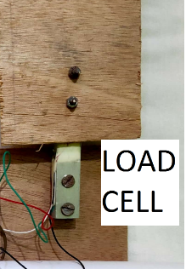

**Fig 2.1 : Operation of Load Cell**

Colour code in this picture shows :

Red = + excitation

Black = - excitation

Green = + signal

White = - signal

**2.1.2 HX711**

The Load Cell electronic component is a tiny amplifier breakout board for the HX711 IC that permits one to simply study load cells to determine weight.The changes in resistance offered by the Load Cell need to be amplified so that they can be read by an arduino.That is exactly what the HX711 board does. It reads the data from the Load Cell, amplifies the signals, after amplification it is sent to the arduino for processing.

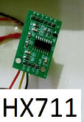

**Fig 2.2 : An HX711 Amplifier**

The signal from HX711 is very small. Therefore after connecting the amplifier to the output of HX711 the signal is amplified upto the desired level so that the microcontroller will be able to detect the electrical signal from sensor. By properly calibrating the sensor one will get weight measurements with very high accuracy.

The HX711 exploits a 2 wire interface (Clock and Data) for communication. Any microcontroller General Purpose Input and Output pins ought to work, and diverse libraries are written, facilitating the detection of data from the HX711.

**2.1.2(a)FEATURES**

* Operation Voltage: 2.7V-5V
* Operation Current: < 1.5ma
* Selectable 10SPS or 80SPS output data rate
* Simultaneous 50 and 60Hz supply rejection

**2.1.3 ARDUINO BOARD**

The arduino UNO Revision-3 and other arduino boards are an open-source microcontroller board supported by Microchip. It has ATmega328P microcontroller and it is developed by Massimo Banzi Arduino LLC.The development board has sets of digital and analog General purpose input output pins that will be interfaced to various add-on boards called as shields and several other circuits The board has fourteen Digital pins from D.0 to D.13, six analog pins A.0 to A.5 and these could be programmable with the arduino IDE “Integrated Development Environment”. It is power-driven by a USB cable or by an external 9volt battery, although it accepts voltages from 7-20volts.

**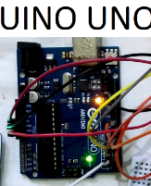  
 Fig 2.3 : An Arduino UNO ATMega328 Board**

**2.1.3(a) TECHNICAL SPECIFICATIONS**

* Microcontroller: Microchip ATmega328P
* Operating Voltage: 5 Volts
* Input Voltage: 7 to 20 Volts
* Digital I/O Pins: 114 from D.1 to D.13 (of which 6 provide PWM output-D.3,D.5,D.6,D.9,D.10,D.11)
* Analog Input Pins: 6
* DC Current per I/O Pin: 20 ma
* DC Current for 3.3V Pin: 50 ma
* Flash Memory: 32 Kilo-Byte of which 0.5 Kilo-Byte is used by bootloader
* SRAM: 2 KB
* EPROM: 1 KB
* Clock Speed: 16 MHz
* Length: 68.6 mm
* Width: 53.4 mm
* Weight: 25 g

**2.1.3(b) GENERAL PIN FUNCTIONS**

* LED: There is an inherent junction Light Emitting Diode driven by digital pin 13. Once the pin is HIGH , the Light Emitting Diode turns on, once the pin is LOW, it's off.
* VIN:The input voltage to the arduino/Genuino board once it's utilizing an external regulated power source. You’ll be able to provide voltage through this pin, or, if supplying voltage through the power jack, access it via this pin.
* 5V: This pin gives a regulated output voltage of 5volts from the regulator on the board. The DC power jack (7-20volts), the USB connection (5volts) or the input voltage VIN pin of the board (7-20volts) is used to drive the Arduino Board. The supply voltage through the 5V or 3.3V pins bypasses the regulator, and can damage or breakdown the circuit in the board.
* 3V3: A 3.3V provided is generated by the on-board regulator. Maximum current draw is 50 ma.
* GND: Ground pins.
* IOREF: This pin on the Arduino UNO Revision 3 board supplies the voltage reference to set the upper limit of Analog to digital converter like 5volts or 3.3volts. a properly configured shield can read the IOREF pin voltage and select the appropriate power source or enable voltage translators on the outputs to work with the 5V or 3.3V.
* Reset: Typically used to add a reset button to shields which block the one on the board, it is a high priority overriding button.

**2.1.3(c) COMMUNICATION**

Arduino will be used to communicate with a system, another arduino board or different microcontrollers. The ATmega328P microcontroller provides UaRT TTL (5V) serial communication which might be done using digital pin 0, D.0(Rx) and digital pin 1, D.1(Tx). An ATmega16U2 that has firmware pre-installed in it for the transfer of data from computer to ATMega328 and vice-versa channels this serial communication over USB and seems as a virtual comport to software-package on the system. The aTmega16U2 computer code uses the regular USB COM drivers, and no external driver is required. Furthermore, on Windows operating system, a .inf file is reqiured. The arduino package includes a serial monitor that permits easy textual piece of informaton-data to be sent to and from the arduino board. There are 2 receiving and transmitting Light Emitting Diode on the arduino board which will flash once the information-data is transmitted via the USB-to-serial chip and USB interaction to the system (not for serial communication on pins D.0 and D.1). A Software-Serial library permits for serial communication on any of the Uno's digital pins. The aTmega328P furthermore supports I2C (TWI) and SPI communication. The arduino package includes a Wide library to alter the utilization of the I2C bus.

**2.1.4 BOLT WIFI MODULE**

The ESP8266 (and the newer ESP32) have extremely agitated the universe of IoT from being just about a novelty industry (we all bear in mind the fridges that tweet and ovens that force us to accept an end user licence agreement) into a subject-citizen science revolution where sensors across the world are observing temperature change, animal migration patterns and far more.

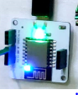

**Fig 2.4 : Bolt WiFi Module**

However, all of those sensible concepts needs a power source and the ESP8266 has become the go-to board extremely down to price, and not for its simple use. However there are boards out there, supported by the ESP8266, that provides a simple to use interface that we will use to program the board to perform the desired tasks as per our requirement.

**2.1.4(a) PARAMETERS of BOLT WIFI MODULE**

|  |  |
| --- | --- |
| Connector and Processor Module | ESP8266 + Custom FirmWare |
| MCU | 32-bit RISC CPU: Tensilica Xtensa LX106 |
| Power | 5volts/1ampere DC via Micro-USB port or 5volt and Ground pins |
| Operating Voltage | 3.3V |
| CPU Clock Frequency | 80 MHz |
| MCU Internal Memory | 64 Kilo Byte of instruction Radom Access Memory;  96 Kilo Byte of data RAM |
| MCU External Memory | 4 Mega Byte Flash memory [QSPI] |
| GPIO pins | 5 Digital pins [3.3V logic] |
| ADC | 1 pin 10 bit ADC [0-1V input PWM] |
| Pulse Width Modulation Pins | D.3, D.5, D.6, D.9, D.10, D.11 |
| Connectivity | WiFi:802.11 b/g/n |
| Automatic AP mode if not connected to Wireless Fidelity |  |
| WEP/WPA/WPA2 authentication |  |
| UART 8-N-1 3.3V TTL UART [using TX, RX, GND pins] [9600 baud rate] |  |

**2.1.5 RELAY**

Relay is a device that acts as a switch similarly as a controlled switch to come up with output in step with the necessity or our alternative.They're typically employed in all physical circuits to map the speed of the opposite devices and manage them correctly.During this project model , it's being employed for the exact same purpose.

**Fig 2.5 : Relay**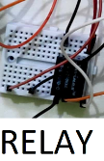

**2.1.6 POWER SUPPLY**

Whenever we talk about the components of the circuit we often ignore the most important of it which is power supply.In a circuit there are several components, some work on ac and some work on dc supply. Every component has a different working range and different system.

So, power supply is crucial as it gives power to every component.



**Fig 2.6 : Power Supply**

**2.1.7 LoRa based on Chirp Spread Spectrum**

In this modulation technique deployed for LoRa, a frequency-varying chirp signal is generated , which in turn is used to obtain the spreading of the spectrum.Thus, in this way the complexities in the receiver design are done away with, since complex algorithms are avoided. Due to the Chirp Spread Spectrum technique employed , the LoRa Modulation Technique is also known as CSSS.

**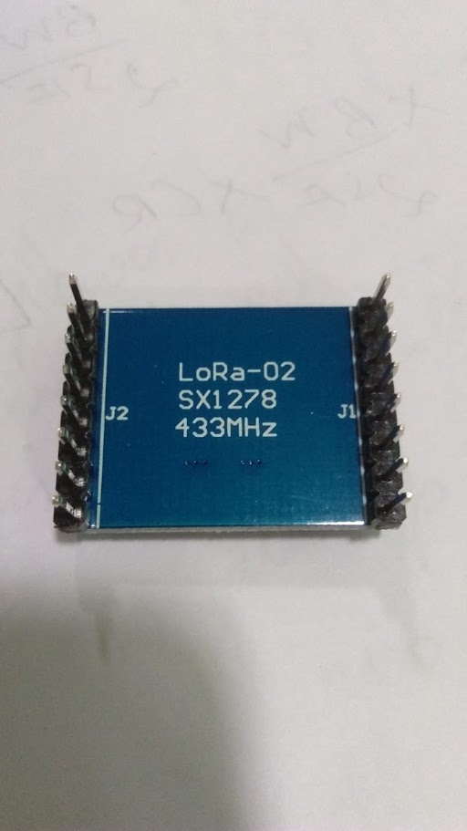  
Fig 2.7 : Rear view of LoRa Module**

**2.2 SOFTWARE USED**

**2.2.1 ARDUINO IDE**

The Arduino integrated development atmosphere (IDE) is such an application that may be deployed across several platforms like Windows, mac OS and UNIX operating system, Java being the artificial language. It is used to write and transfer programs to Arduino compatible boards. However with the help of third party cores, it also can be used to transfer codes to alternative merchant development boards.

The languages supported by the Arduino IDE square measure primarily C and C++ , additionally to that special rules of code structuring square measure used, as could also be compatible.

User-written code includes 2 basic functions, one for beginning the sketch and also the alternative one being the most program loop, that square measure compiled and joined with a program stub main() into an feasible cyclic computer programme with the help of wildebeest tool-chain, that's enclosed with the IDE distribution.

The Arduino IDE uses the program avrdude to perform the conversion of feasible code into a document in hex that's finally loaded into the Arduino board , that a loader program within the board's code is used.

**2.2.2 UBUNTU VMWARE WORKSTATION**

VMware WorkStation Player (which was earlier called as Player Pro) may be an efficient desktop virtualization application that is used to run quite one software system on a similar computer while VMware digital computer Player brings to its users a straightforward nevertheless interactive interface, unmatched software system support, and movability.

To the software system that's running within the virtual machine(also called guest operative system), it appears as if it's running severally on its own computer. The host software system is employed to work the VMware digital computer Player, that provides the guest with resources like network access and also the like.It is on the market on-line for free of charge downloading on VMWare.

Virtual machines that square measure organized with an OS and applications that square measure able to perform a particular square measure called virtual appliances. Several such appliances will be created victimisation bound VMware merchandise, or one will transfer already ready ones. A good style of these appliances (both certified and other-wise) square measure on the market from VMware's Appliance Marketplace.

**2.3 BOLT IOT CLOUD PLATFORM**

Bolt is an IoT platform that's used to simply and quickly build IoT merchandise that square measure quick-emerging these days. Bolt is supplied with a WiFi/GSM chip and a cloud platform that assists the user to attach the devices and sensors to the web.

As one more advantage, with the assistance of Bolt Cloud one will manage and monitor those self same devices and sensors over the web, produce customized dashboards for visualizing the information, monitor the health of the device , run machine learning algorithms and also the list goes on.

Building climbable IoT systems in exactly a days time becomes extraordinarily fluent with the information of this platform.

**CHAPTER 3**

**WORKING OF THE PROJECT MODEL**

##### The individual components are integrated together to perform the desired task and circuit diagram is made.

**3.1 CIRCUIT DIAGRAM**

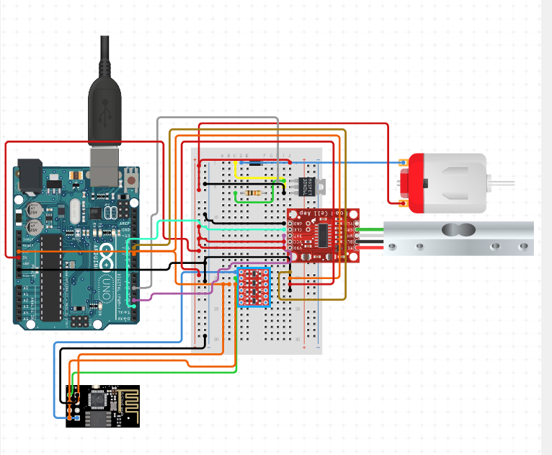

**Fig 3.1 : Diagram of Circuit Connection of Load Cell with various components**

**3.2 PROJECT DESCRIPTION**

The 5V of the Uno is connected to VCC and GND to GND

**3.2.1 LOAD CELL TO HX711 CONNECTION**

The HX711 amplifier.

D-P: 4 and CLK: 5.

E+ : RED

E- : BLACK

A- : GREEN

A+ : WHITE

B- : NO conx

B+ : NO conx

**3.2.2 HX711 TO ARDUINO CONNECTION**

GND : GND  
DT : digital pin ---->6  
SCK : digital pin ---->5  
VCC : 5V

**3.2.3 ARDUINO TO BOLT IOT CONNECTION**

Digital pin 2 : Digital pin 0

**3.2.4 ARDUINO TO LoRa MODULE CONNECTION**

3.3 V : 3.3 V

GND : GND

Digital pin 3 : DIO0  
Digital pin 8 : Tx Antennae

Digital pin 9 : RST

Digital pin 10 : MOSI

Digital pin 11 : SCK

Digital pin 12 : MISO

**3.3 WORKING**

We are using a load cell of 1kg rating that means the maximum weight it can measure is 1kg (1000g). In Arduino code we have fixed  the threshold weight as 150g, if the weight on the load cell is greater than 150g, the digital output pin 2 of Arduino becomes HIGH and since it is connected to digital input pin 0 of bolt wifi module which was initially LOW and so as soon as it gets HIGH, the bolt IoT module(ESP8266) will send signal to bolt IoT cloud. For message and Email services we have used trial versions of Twilio and Mailgun. The bolt cloud will request Twilio and Mailgun to send messages and mail to our phone number and Email ID with the credentials we have entered in the code. But, since the Twilio and Mailgun are effective as long for alerting the driver only, we have incorporated another communication module, LoRa, which has a range of 10-15 kilometres. So, in this way a police station in the vicinity can be alerted and that comes out as an added precaution in curbing accidents. The workflow diagram for the same is illustrated below -

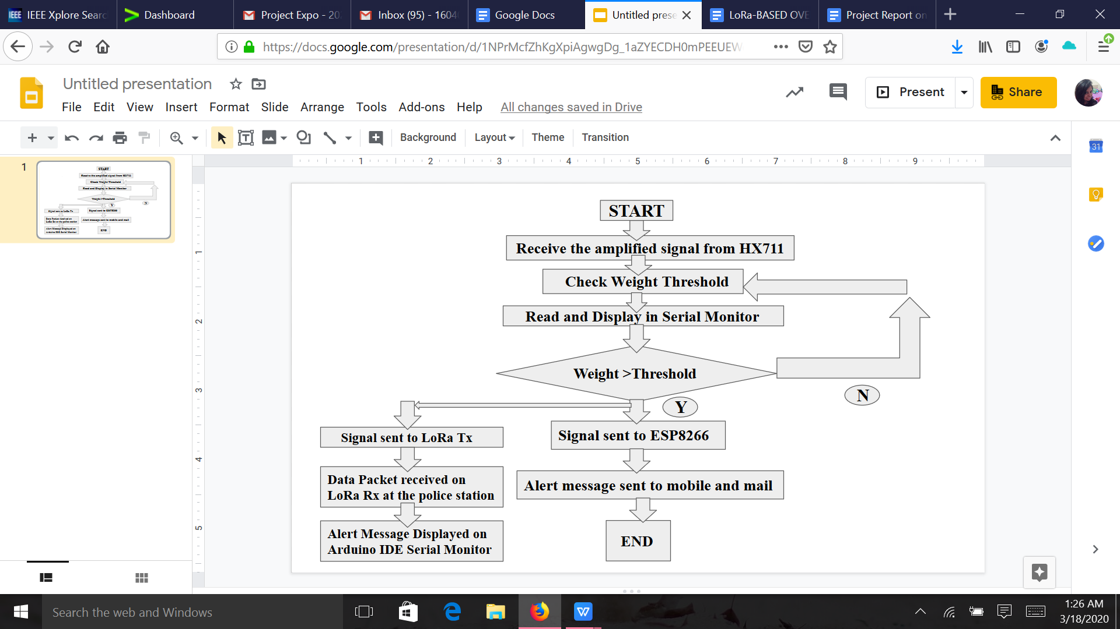  
**Fig 3.2 : WorkFlow Diagram**

**3.3.1 CODE**

The scale was set up and the was done without putting on the weight

The weight should be put after noting the default weight

The calibration factor was set up by the use of a and z as well as plus and minus

Arduino -> HX711

pin 6 -> CLK

pin 5 -> DOUT

pin 5V -> VCC

pin GND -> GND

**Codes which was used to calibrate the load cell**

#include "HX711.h"

HX711 scale(6, 5);

//float cali_fact = 8;

float cali_fact = 1100; // this cali fact will vary from load cell to load cell

float weight;

void setup() {

Serial.begin(9600);

Serial.println("The sketch used for the calibration");

Serial.println("Put zero weight");

Serial.println("Put the weight that we already know");

Serial.println("use key to increase or decrease");

Serial.println("use key to increase/decrease");

scale.set_scale()

pinMode(2, OUTPUT);

long zee_fact = scale.read_averageofvalues();

Serial.print(“0 factor: ");

Serial.println(0 factor);

}

void loop() {

scale.set_scale(cali_fact);

Serial.print("Reading: ");

units = scale.get_weights(), 1000;

if (units < 0)

{

weight = 0.00;

}

Serial.print(weights);

Serial.print(" kilograms");

Serial.print(" cali_fact: ");

Serial.print(cali_fact);

Serial.println();

if(units>200.0)

{

digitalWrite(1, HIGH);

}

if(units<300.0)

{

digitalWrite(1, LOW);

}

if(Serial.available())

{

char temp = Serial.read();

if(temp == '+++' || temp == 'aaaa')

calibration_factor += 1;

else if(temp == '----' || temp == 'zzzzz')

calibration_factor -= 1;

}

delay(1000);

}

**CHAPTER 4**

**FUTURE SCOPE OF ENHANCEMENT**

**4.1 USING DATA FROM ARDUINO TO INCLUDE SEATBELT AS A MANDATE**

The same cloud database can be equipped with the other data sets of the passenger. Let’s say this in a simple way. If the vehicle is running and the driver is not wearing a seatbelt, this information can also be uploaded to a cloud database and then we will send the information of overloading and seatbelts together to the concerned authorities. In this way the driver will be forced to wear seatbelts. Currently, the OCS sensors are used for the detection of the seatbelts and airbags. We will have to just move that data of the sensors to our cloud and the work is done.We can also see the time for which the car was running and time for which the driver had seat belts on because the drivers generally wear seatbelts when they see traffic police nearby just to avoid being caught.

**4.2 IN-BUILT CAMERA FOR DETECTION OF BLACK SPOT**

The vehicles like trucks and volvo buses are very large in shape and size. There are many areas where drivers cannot see.We have seen accidents on toll booths at night also because the drivers of trucks are not able to see the smaller vehicles just in front of them if their lights are off . We will try to install the cameras which will cover all the blind spots where the drivers cannot see and display it on the screen near the dashboard where drivers can see it easily. Using this method, various major road accidents can be avoided.

**4.3 USING CLOUD STORAGE FOR RETRIEVING LIST OF VIOLATORS**

**AND REPORTING TO THE RULES & REGULATIONS AUTHORITY**

The drivers become very ignorant about the traffic rules once they get the driving license. The real data collected by the sensors can be uploaded to the cloud which will be accessible by the traffic department.The GPS can be used to detect that at which are the rules have been violated and the data will be uploaded to local cloud servers of that area.

**CHAPTER 5**

**CONCLUSION**

**5.1 SUMMARY**

The design model of **“Overload Detection System”** that has been proposed,can be implemented on a large-scale that could help minimize to a great extent the accidents that are presently occurring. With the added scope of enhancement , the vehicles can actually be transformed into bots that ensure nothing but the safety of the human beings operating it.

However, there are a few shortcomings to this too. For the load cells to detect the overweighting of the vehicle and turn off the ignition, they must be calibrated with a certain threshold limit of the value of the weight beyond which it is supposed to produce effect. Now, this value of weight is not the same for all types of vehicles that are operating on the road - one one hand this calibration weight value would lie within a range of 500 kilograms for a normal van that is playing with a school or some institution, the weight would increase to 10 times of this range or even more than that if it is being calibrated for the carriers that operate on the highways.

So, a careful calibration of the model with the corresponding vehicle is required so as to ensure the proper implementation of the technique being designed.One more additional requirement being, skilled man power for the operation of these “smart vehicles” since a very basic knowledge of it is required , just in case to overcome any unwanted emergency that might arise.

**5.2 WEIGHT BUDGET ANALYSIS**

The weight of the working model must be optimized to the best possible level so that it does not add any extra burden to the vehicle. This is the main requirement as to why a weight budget analysis must be done. Here, in the budget the weights of the various computing equipment such as the arduino , Incremental encoder,etc. are included.

|  |  |  |  |  |
| --- | --- | --- | --- | --- |
| **S.no.** | **Item** | **Weight** | **Qty** | **Total** |
| 1. | Arduino UNO | 25 grams | 1 | 25 grams |
| 2. | HX711 | 20 grams | 1 | 20 grams |
| 3. | Load Cell | 150 grams | 1 | 150 grams |
| 4. | Servo Motor | 9 grams | 1 | 9 grams |
| 5. | Bolt IoT WiFi Module | 20 grams | 1 | 20grams |
| 6. | LoRa Module with antennae | 10 grams | 2 | 20 grams |
| 7. | Connecting Wires | 0.5 grams | 20 | 10 grams |
|  | TOTAL |  |  | 254grams |

**5.3 COST ANALYSIS**

The act of breaking down the cost summary into its constituent components and analysing and reporting on each individual segment is known as cost analysis. For the project described, the cost analysis is tabulated as follows -

|  |  |  |  |  |
| --- | --- | --- | --- | --- |
| **S.no.** | **Item** | **Price(in Indian Rupees)** | **Qty** | **Total** |
| 1. | arduino UNO | 350 | 1 | 350 |
| 2. | HX711 | 90 | 1 | 90 |
| 3. | Load Cell | 280 | 1 | 280 |
| 4. | DC Motor | 140 | 1 | 140 |
| 5. | LoRa Module | 800 | 2 | 1600 |
| 6. | Bolt IoT WiFi Module | 500 | 1 | 500 |
| 7. | Connecting Wires | 3 | 20 | 60 |
| 8. | Motor Driver | 200 | 1 | 200 |
|  | TOTAL |  |  | 3,220 |

**5.4 RESULT IMAGE**

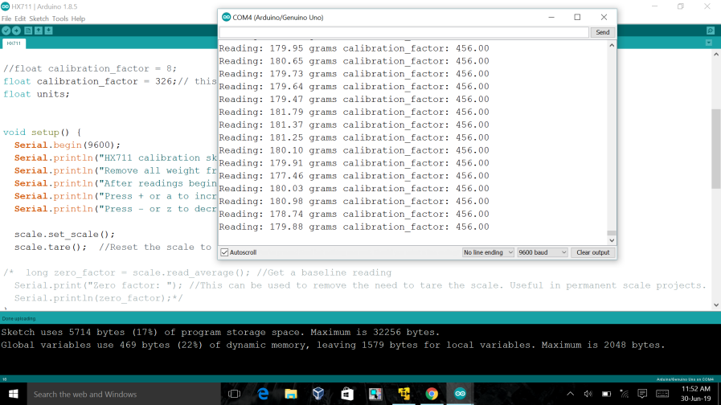

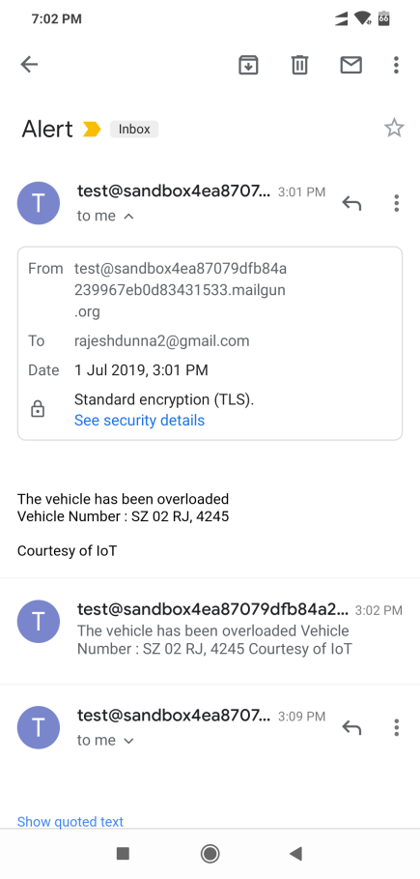 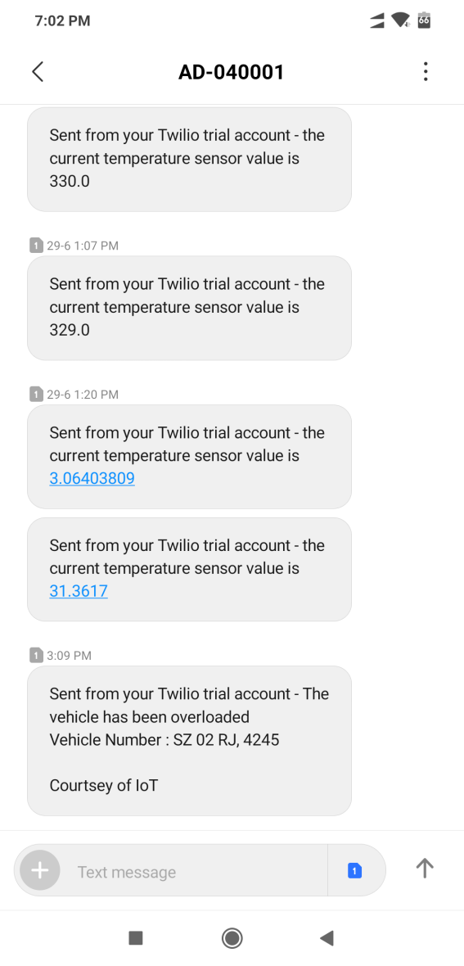

**CHAPTER 6**

**PLANNING & REFERENCES**

**6.1 PLANNING AND PROJECT MANAGEMENT**

|  |  |  |  |
| --- | --- | --- | --- |
| **S.No.** | **activity** | **Starting Week** | **Number of Weeks** |
| 1. | Literature Review | 1st week of January | 2 |
| 2. | Project Finalization | 3rd week of January | 1 |
| 3. | Permission for required software | 4th week of  January | 1 |
| 4. | Gathering of Hardware & Formation of codes | 1st week of February | 1 |
| 5. | Hardware assembly calibration | 2nd week of February | 1 |
| 6. | Code Integration & Debugging | 3rd week of February | 2 |
| 7. | Inclusion of IOT and  LoRa Module | 1st week of  March | 1 |
| 8. | Testing/Modification of Working model | 1st week of  March | 1 |
| 9. | Preparation of project report | 2nd week of March | 1 |
| 10. | Preparation of Project presentation | 3rd week of  March | 1 |

**The Gantt Chart is shown below -**

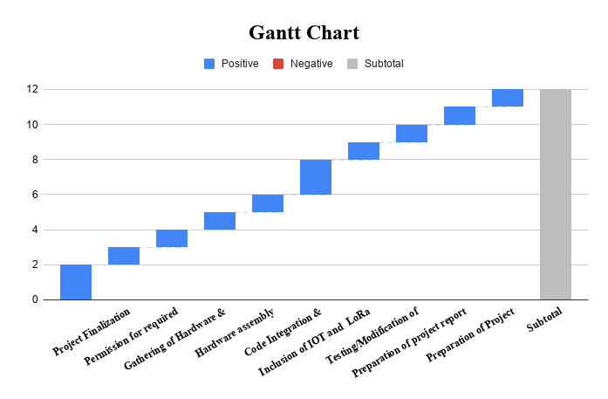

**REFERENCES**

[1] Road accident statistics in India, Jan 2018, [online] Available: <http://sites.ndtv.com/roadsafety/important-feature-to-you-in-your-car-5/>.

[2] Firoozian and Riazollah, ‘Servo Motors and Industrial Control Theory Edition 2’.

[3] Jacob Millman and Halkias ‘Millman’s Integrated Electronics Second Edition’

[4] Jihun Han, antonio Sciarretta Luis Leon Ojeda Giovanni De Nunzio Laurent Thibault ‘Safe- and Eco-Driving Control for Connected and automated Electric Vehicles Using analytical State-Constrained Optimal Solution’ Volume: 3 , Issue: 2 , June 2018 )

[5] Jie Zhang, Jinlong Hong, Bingzhao Gao Hong Chen ‘Creep speed tracking control of the aMT vehicles’ 2017 36th Chinese Control Conference (CCC).

[6] Yulei Liao Yongjie Pang Lei Wan ‘Combined speed and yaw control of underactuated unmanned surface vehicles’ 2010 2nd International asia Conference on Informatics in Control, Automation and Robotics (CaR 2010).

[7] Liu Dapeng Xu Yong Zhang Xiangwen ‘Design of speed control system for vehicle road train based on CaN’ 2013 Chinese automation Congress.

[8] Hua Chen Lin Liu Yu Zhang Yantao Tian adaptive speed control of autonomous vehicle under changing operation conditions 2017 36th Chinese Control Conference (CCC).

[9] Jin Maojing ‘Improvement of Road-following Intelligent Speed Control Based on Road Curvature’ 2013 Third International Conference on Intelligent System Design and Engineering applications.

[10] Nagarjuna R, Vatti Prasanna, Lakshmi Vatti, Rambabu Vatti, Chandrashekhar Garde ‘Smart Road accident Detection and communication System’ 2018 International Conference on Current Trends towards Converging Technologies (ICCTCT).

[11] Taieba Taher ; R. U. Ahmed ; M. a. Haider ; Swapnil Das ; M. N. Yasmin ; Nurasdul Mamun ‘accident prevention smart zone sensing system’

2017 IEEE Region 10 Humanitarian Technology Conference (R10-HTC).

**SELF DECLARATION FOR PLAGIARISM CHECK**

We, Anjali Chatopadhyay(1604074), Dunna Rajesh(1604082), Himanshu Agarwal(1604084), Sahil Sinha(1604102) and Sneh Shyambhavi(1604113) are declaring that our Project report on “LoRa-BASED OVERLOAD DETECTION SYSTEM FOR TRANSPORTATION” has plagiarism well within the limits prescribed to us. We take the full responsibility of it.